Physics Stage 3: Particles, Waves and Quanta 2010

Test One
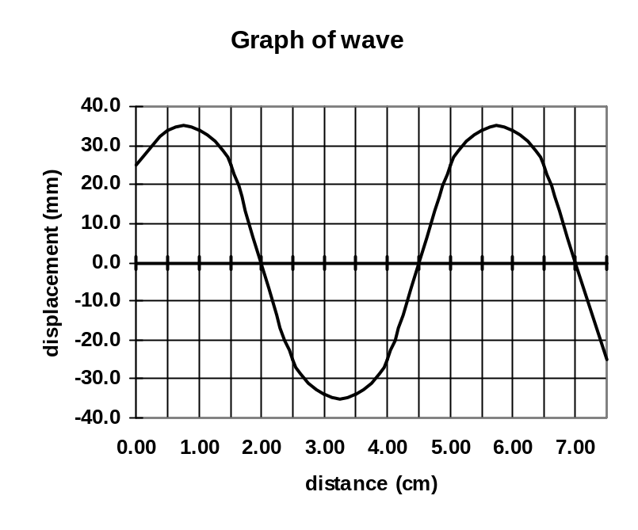Name: Possible Answer Key (40 marks)
- Three students are using a piece of string to make a standing wave. The following graph shows the wavelength of part of the string at one particular instance. What is the amplitude and wavelength of the wave the string creates. (2 marks)

Amplitude 3.50 x 10⁻² m

Wavelength 5.00 x 10⁻² m

- If the wave in the graph for question (1) is travelling at 4.00 ms⁻¹, what is the period of the wave? (3 marks)

v = λf
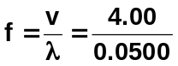

T = 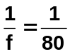 T = 0.0125
T = 1.25 x 10⁻² s

- Complete the following: (3 marks)
- In a region of stationary waves, nodes indicate minimal (or no) vibration of particles.
- The number of waves in a given time. frequency
- The distance between two crests on a displacement / time graph is called the wavelength

- Waves can travel as longitudinal waves or transverse waves. Fully explain the difference giving one example of each. (3 marks)
- Transverse – particles vibrate perpendicular to direction of wave e.g. light.
- Longitudinal – particles vibrate parallel to direction of wave e.g. sound

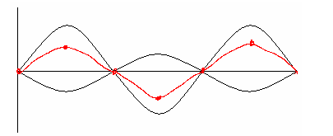

- A student has set up two waves on a dual beam CRO. She then adds them together.
Draw the resultant wave. (2 marks)

- Bending of waves due to passing around or through openings is called diffraction
(1 mark)
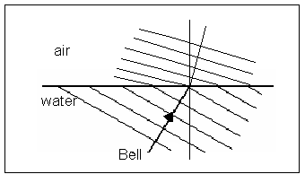
- Complete the following diagrams for reflection of waves at harbour wall and refraction of sound of bell above water. (3 marks)
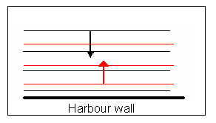
(1 mark) (2 marks)

- Matt starts by running his finger around the top of a wine glass. He then increases the speed until it sounds a note. Explain why the glass sounds the note and what is the name given to this phenomena. (3 marks)

Phenomena is resonance.
- Wine glass forced to vibrate by finger running around top.
- When sound is heard, frequency of forced vibrations matches natural frequency of glass
- At resonance, vibrations of glass greatly increased and a sound is produced.

- Andrew is blowing air over the end of a pipe. When he blows softly across the end, a microphone connected to a C.R.O. shows a frequency of 256 Hz. When he blows over the pipe much harder, a frequency of 1024 Hz is shown on the screen. The speed of sound on the day is 332 ms⁻¹.
  - Is the pipe open at both ends or open at one end and closed at the other? (1 marks)
open at both ends
  - Fully explain the answer you gave. (3 marks)
ratio of frequencies 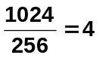 therefore in 4th harmonic when blew harder.
Only open ended pipes have even harmonics as an antinode is needed on an open end.
Closed pipes have a node at one end and an antinode at the other end so can’t have even harmonic.

  - What is the length of the pipe assuming the 256 Hz is the fundamental frequency?
(2 marks)

f = 256 Hz 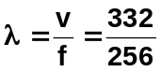
v = 332 m s⁻¹ λ = 1.297 m

length of pipe = ½ λ = ½ λ
= ½ x 1.297
= 0.649 m
- A closed pipe is 40.0 cm long and is made to vibrate in its fundamental frequency. What is the period of the wave? (3 marks)

length of pipe = ¼ λ 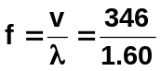
λ = 4 x f = 2.16.25 Hz
= 4 x 0.400
= 1.60 m 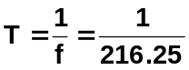
v = 346 m s⁻¹
T = 4.62 x 10⁻³ s

- Waves can be either mechanical waves or electromagnetic waves.
  - Give two difference between them. (2 marks)
speed – electromagnetic waves always at 3 x 10⁸ m s⁻¹, mechanical waves vary
mechanical waves need a medium, electromagnetic waves do not
  - Electromagnetic waves are said to be both wave-like and particle-like. Explain this dual nature of light. (2 marks)

Wave-like in that they exhibit wave behaviour – reflection, refraction and
diffraction.

Particle-like as shown by the photoelectric effect and spectrums

- An astronomer is observing cosmic microwaves which are the remnant signal of the birth of our Universe in the Big Bang. Which of the following types of telescopes would he be using.
    - Infra-red telescope
    - Light telescope
    - Radio telescope
    - Ultra-violet telescope
    - X-ray telescope. Answer: C (1 mark)

- Radio-waves and X-rays travel at the same speed even through their energy is very different.

  - Which has the higher energy? X-rays (1 mark)
  - Explain why they both travel at the same speed. (1 mark)

Both are electromagnetic waves produced by the interaction of changing electric and magnetic fields.

- The two speakers below are producing a 680 Hz note. Assume the speed of sound in air is 340 ms⁻¹. Point P is 10.00 m from speaker A and 12.75 m from speaker B.

P
A 10.00 m

12.75 m
B

Determine if there is a node or anti-node at point P and what would be hear at this point. You must justify your answer to receive any marks. The wave position next to the speakers is an anti-node. A diagram may assist your answer. (You may need to complete this on the back of this page). (4 marks)

f = 680 Hz 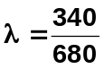
v = 346 m s⁻¹ λ = 0.500 m (1 mark)

Consider wave A
λ = 0.5 m 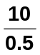 = 20 full waves, so as an antinode at start, must be an antinode at end.
(1 mark)

Consider wave B
λ = 0.5 m 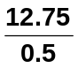 = 25.5 or 25 full waves and half a wave.
so would be an anti-node but on the opposite side to a full
wave as shown in the diagram below. (1 mark)

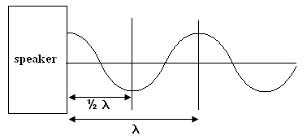

As the two antinodes are opposite each other, there will be total annihilation producing no sound (or very minimal) (1 mark)

